Project Design Phase Problem – Solution Fit Template

Date | 15 February 2025
Team ID | LTVIP2026TMIDS78241
Project Name | LearnHub: Your Center for Skill Enhancement
Maximum Marks | 2 Marks

Problem – Solution Fit Template:
The Problem-Solution Fit simply means that you have found a problem with your customer and that the solution you have realized for it actually solves the customer’s problem. It helps entrepreneurs, marketers and corporate innovators identify behavioral patterns and recognize what would work and why

Purpose:
- Solve complex problems in a way that fits the state of your customers.
- Succeed faster and increase your solution adoption by tapping into existing mediums and channels of behavior.
- Sharpen your communication and marketing strategy with the right triggers and messaging.
- Increase touch-points with your company by finding the right problem-behavior fit and building trust by solving frequent annoyances, or urgent or costly problems.
- Understand the existing situation in order to improve it for your target group.

Template:
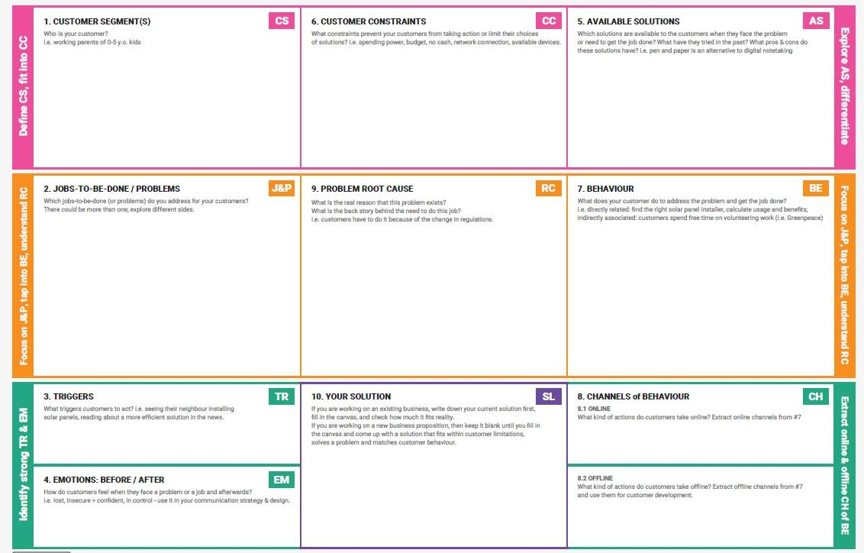
LearnHub – Problem-Solution Fit Analysis: Problem:

Learners today face significant barriers in accessing quality, structured, and affordable skill development resources. Traditional education is rigid, costly, and time-consuming. Professionals and students lack a centralized platform that offers flexible, self-paced learning with certification — making it difficult to upskill and remain competitive in the job market.

Target Customers:
- Students seeking to learn in-demand technical skills (e.g., web development, programming).
- Working professionals looking to upskill or switch careers.
- Expert instructors (e.g., John, experienced developers) who want to monetize their knowledge.

Solution (LearnHub OLP):
- Self-Paced Learning: Learners like Sarah can enroll in courses (e.g., “Web Development Fundamentals”) and progress at their own pace, with the platform saving their progress automatically.
- Interactive Learning: Discussion forums, live webinars, and Q&A sessions foster community and peer learning.
- Certification: Upon course completion, learners receive a digital certificate to showcase in their portfolios.
- Flexible Pricing: Free and paid courses with multiple subscription options allow affordability at different levels.
- Instructor Tools: Instructors can upload, manage, and update courses; admins oversee the platform for smooth operations.

Problem-Solution Fit Validation:
LearnHub directly addresses the identified problems by providing a user-friendly, accessible, and scalable online learning platform. The MERN-based architecture (MongoDB, Express.js, React, Node.js) ensures real-time responsiveness, seamless course management, and cross-device accessibility — validating that the solution fits the target customer’s needs.

References:
- https://www.ideahackers.network/problem-solution-fit-canvas/
- https://medium.com/@epicantus/problem-solution-fit-canvas-aa3dd59cb4fe

